**Project Design Phase-II**

**Data Flow Diagram & User Stories**

|  |  |
| --- | --- |
| Date | 24 June 2025 |
| Team ID | LTVIP2025TMID20421 |
| Project Name | Streamlining Ticket Assignment For Efficient Support Operations |
| Mentor Name | Dr Shaik Salma Begum |
| Maximum Marks | 4 Marks |

**Data Flow Diagrams:**

A Data Flow Diagram (DFD) is a traditional visual representation of the information flows within a system. A neat and clear DFD can depict the right amount of the system requirement graphically. It shows how data enters and leaves the system, what changes the information, and where data is stored.

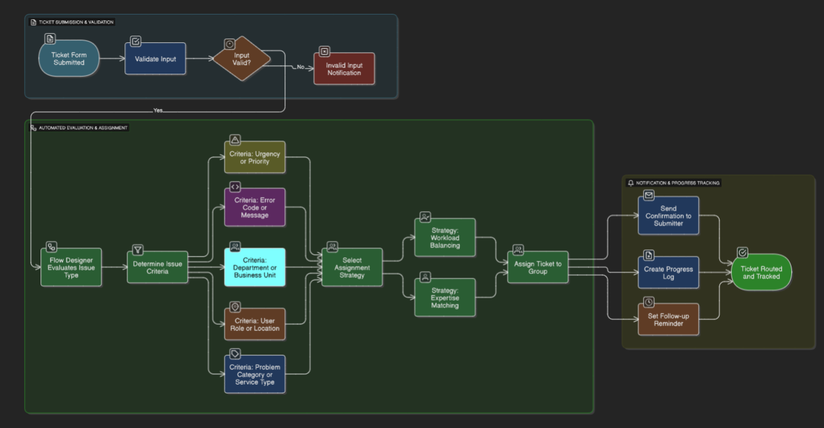

**User Stories**

Use the below template to list all the user stories for the product.

| **User Type** | **Functional Requirement (Epic)** | **User Story Number** | **User Story / Task** | **Acceptance Criteria** | **Priority** | **Release** |
| --- | --- | --- | --- | --- | --- | --- |
| Support Admin (Dev) | ServiceNow Setup | USN-1 | As a developer, I can set up a Personal Developer Instance | Instance is live and accessible for configurations | High | Sprint-1 |
| Support Admin (Dev) | Update Set Creation | USN-2 | As a developer, I can create and activate an update set | Update set is current and tracks changes | High | Sprint-1 |
| Support Admin (Dev) | Table Creation | USN-3 | As a developer, I can create the Operations Related table with issue field | Table is visible, issue field has predefined options | High | Sprint-1 |
| Support Admin (Dev) | User & Group Creation | USN-4 | As a developer, I can create users and assign them to groups | Users are added and associated with correct groups | High | Sprint-2 |
| Support Admin (Dev) | Role Setup | USN-5 | As a developer, I can create roles and assign them to groups | Roles appear under correct group configuration | High | Sprint-2 |
| Support Admin (Dev) | ACL Configuration | USN-6 | As a developer, I can create ACLs for table and fields | ACLs restrict access unless proper roles are assigned | Medium | Sprint-3 |
| Support Admin (Dev) | Role Assignment to Table | USN-7 | As a developer, I can assign platform and certificate roles to table access controls | Only specified roles have read/write access | High | Sprint-3 |
| End User (Support Team) | Automated Routing: Certificates | USN-8 | As a user, I can have tickets with "Regarding Certificates" auto-assigned | Ticket appears in Certificates group queue immediately | High | Sprint-4 |
| End User (Support Team) | Automated Routing: Platform | USN-9 | As a user, I can have login/404/user expired issues assigned to Platform group | Platform group receives matching tickets instantly | High | Sprint-4 |